**Sprint 2 Plan**

**PantryPal**

**July 10, 2023 - July 16, 2023**

**Revision: 1.0.0**

**Revision date: July 9, 2023**

**Goal:** Build on the web app so that it is able to take a user input and give a formatted list of recommendations using the ML recommender while also allowing filters such as a vegetarian option.

**User Story:**

* **As a user, I want a user interface that has a formatted list of recommendations and also responses for errors that I’ve made - 13 Total**
  + Display Recipes: Creating a function to take the API response and format it into a user-friendly display of recommended recipes. **(3)**
  + Handle No Results: Implement a clear and friendly message to display to the user in case no matching recipes are found. **(5)**
  + Error Handling: Handles potential errors, if the API is down or a request fails, the user should be informed appropriately. **(5)**
* **As a user, I want a variety of recipes based off the ingredients I input 5 total**
  + Build database: Run webscraper on recipe websites and build a large dataset **(5)**
* **As a user, I want to receive recipe recommendations through the user interface 4 total**
  + Integrate ML Model: Adapt ML model to work with endpoint **- 2 Total**
  + Error Handling and Logging: Add comprehensive error handling and logging to Flask API to ensure it fails gracefully and logs the error, and continues with the remaining tasks. **- 2 Total**
* **As a user that's vegetarian, I want to be able to only receive vegetarian recipes that can be made with the ingredients I input. 8 total**
  + Preprocess dataset with only vegetarians options **(4)**
  + Tune model to best generate valid vegetarian recipes **(4)**

**Team roles:**

* **Sayak:** Product Owner, Frontend Developer
* **Aaron:** Backend Developer
* **Yera:** Scrum Master, Frontend Developer
* **Hisham:** Scrum Master, Frontend Developer
* **Raghavendra:** ML engineer
* **Zhengheng:** ML engineer

**Initial task assignment:**

* **Sayak:** As a user, I want a variety of recipes based off the ingredients I input
* **Aaron:** As a user, I want to receive recipe recommendations through the user interface
* **Yera:** As a user, I want a user interface that has a formatted list of recommendations and also responses for errors that I’ve made
* **Hisham:** As a user, I want a user interface that has a formatted list of recommendations and also responses for errors that I’ve made
* **Raghavendra:** As a user that's vegetarian, I want to be able to only receive vegetarian recipes that can be made with the ingredients I input.
* **Zhengheng:** As a user that's vegetarian, I want to be able to only receive vegetarian recipes that can be made with the ingredients I input.

**Initial Scrum Board:**

[**https://pantrypal.atlassian.net/jira/software/projects/SCRUM/boards/1**](https://pantrypal.atlassian.net/jira/software/projects/SCRUM/boards/1)

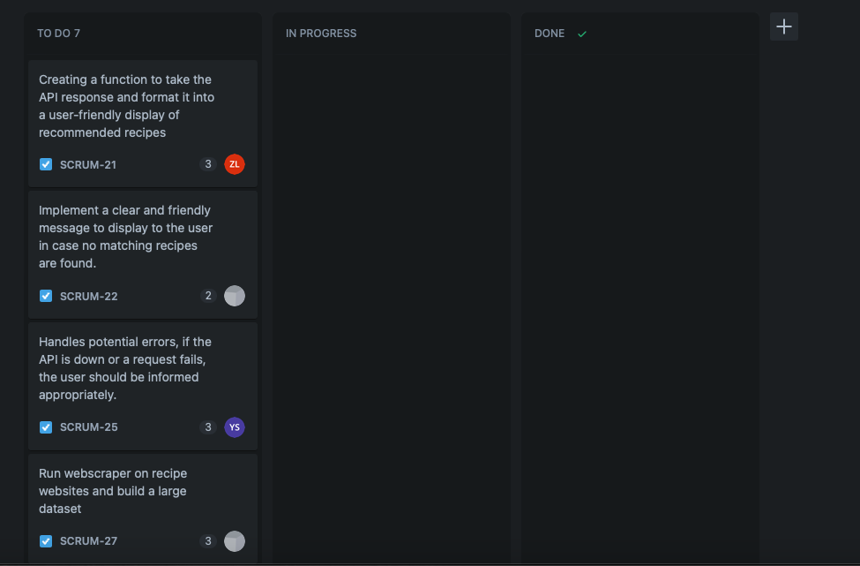

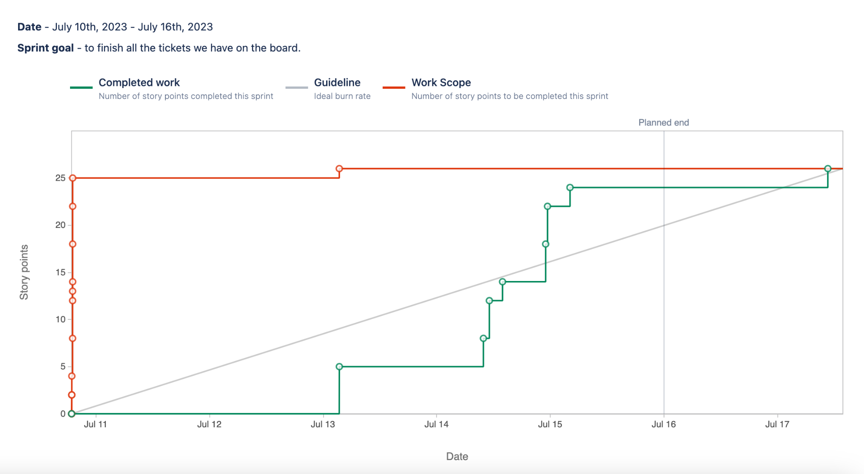

**Scrum Times:**

Mondays: 6-7pm, Wednesdays: 5-6pm, Fridays: 5-6pm